Name of Student: Husam Ali Abdalla Nour | PRN:25070122086
Semester: III | Year : AY 2026-27
Subject: Programming with Java
ASSIGNMENT No : 14
TITLE : Exception Handling using Try-Catch
Problem Statement
Write a Java program to demonstrate exception handling using try and catch blocks,
nested and multiple try-catch blocks.
Learning Objectives
To handle runtime exceptions using try-catch, nested try, and multiple catch blocks.

Programme
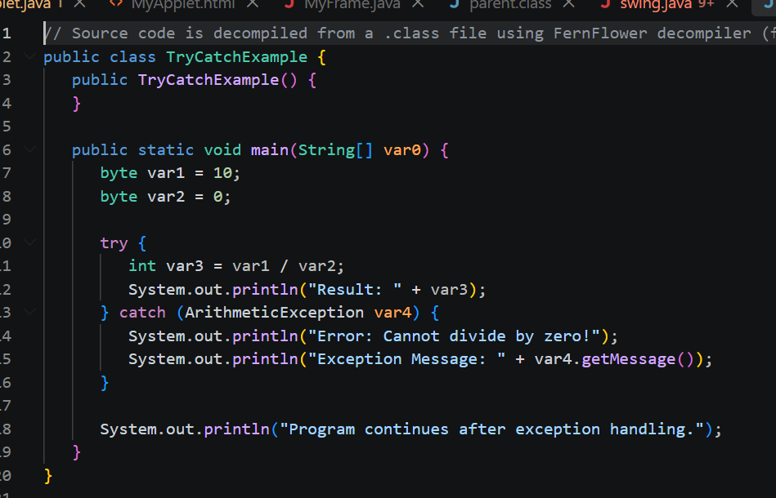
Output
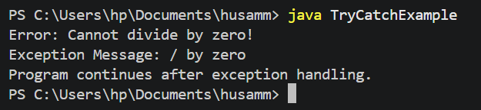
Practice questions
1.Create an ATM program handling invalid withdrawal amount using try-catch.
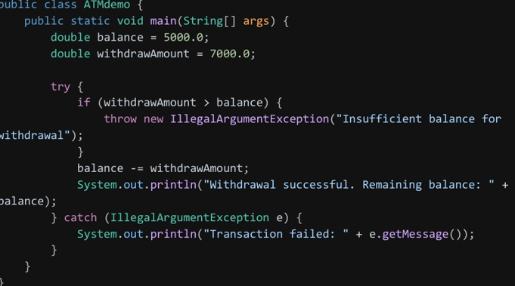
Output
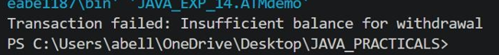
2.Create an Online Shopping program that handles an invalid product quantity entered by the user using a try-catch block. Display an appropriate error message if the quantity is less than or equal to zero.
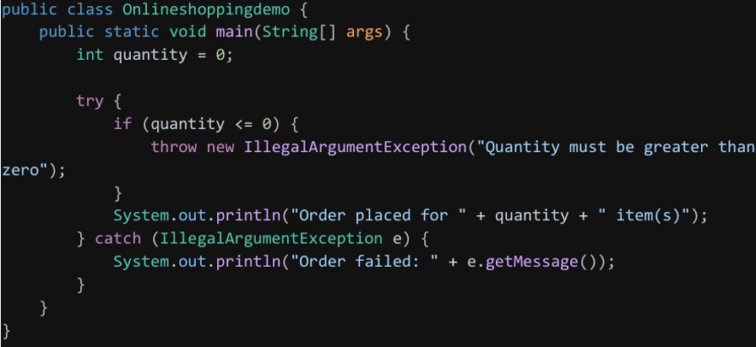
Ourtput
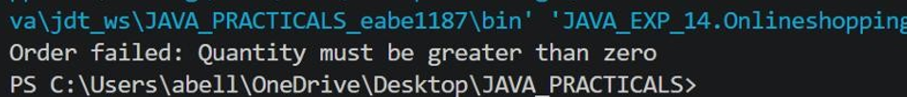

Conclusion
Exception handling allows a Java program to detect and respond to runtime errors gracefully instead of crashing. Multiple catch blocks let a single try block respond differently depending on the exception type, while nested try-catch supports handling errors at different levels of a program's logic together making applications more robust and user-friendly.

